**FRUIT SHOP LANDING PAGE**

name : A.S. AFFAAN SAFI

email : 20at1a0503@gpceet.ac.in

phone no **:**  7013104852

Roll NO : 20AT1A0503(CSE )

College Name : G . Pullaiah **College of Engineering & Technology**

**SOURCE CODE** :

**HTML CODE.html** :

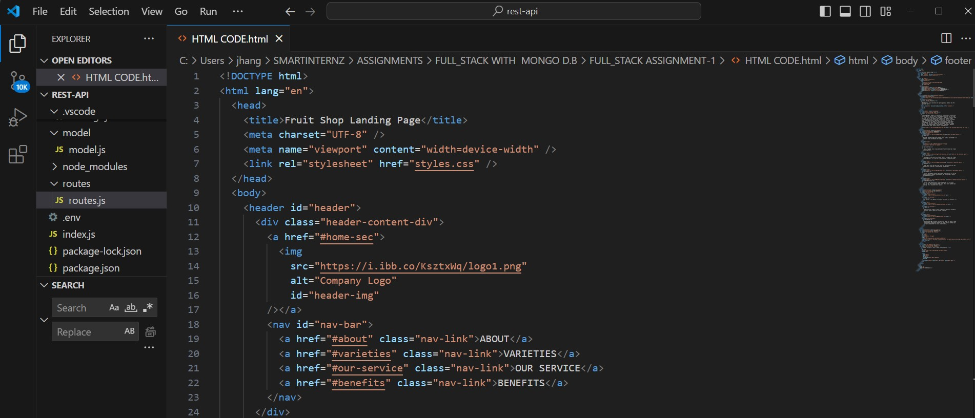

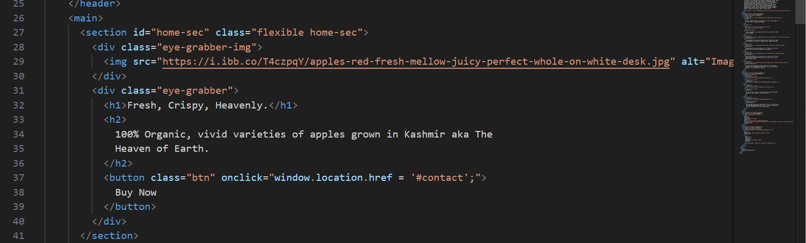

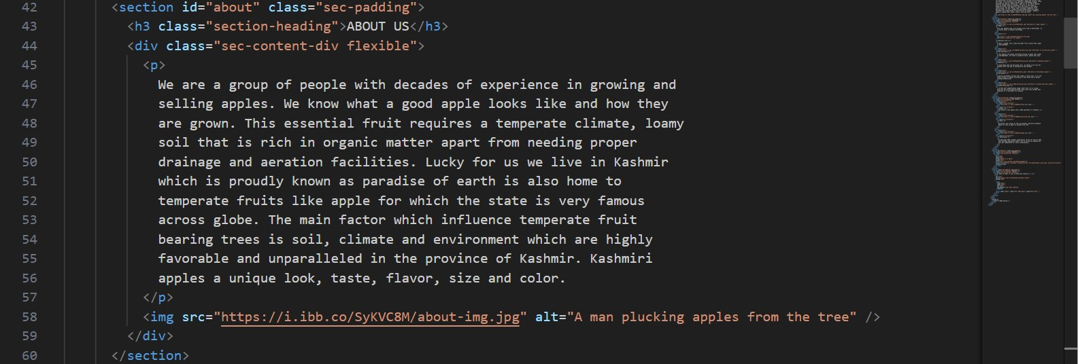

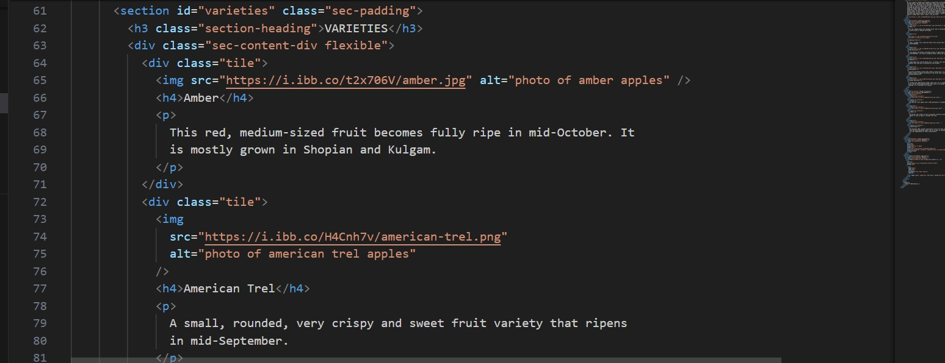

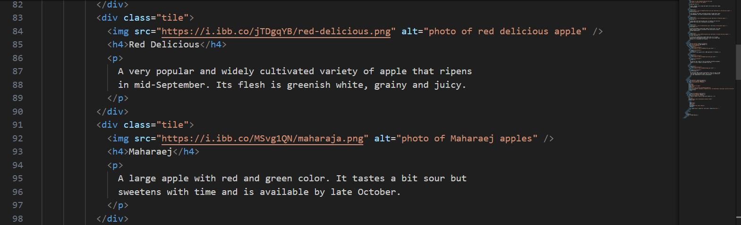

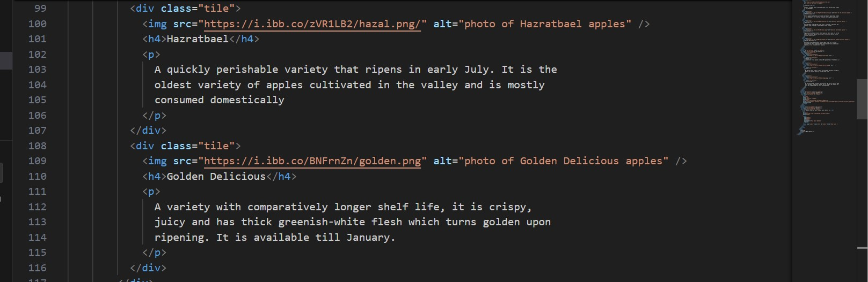

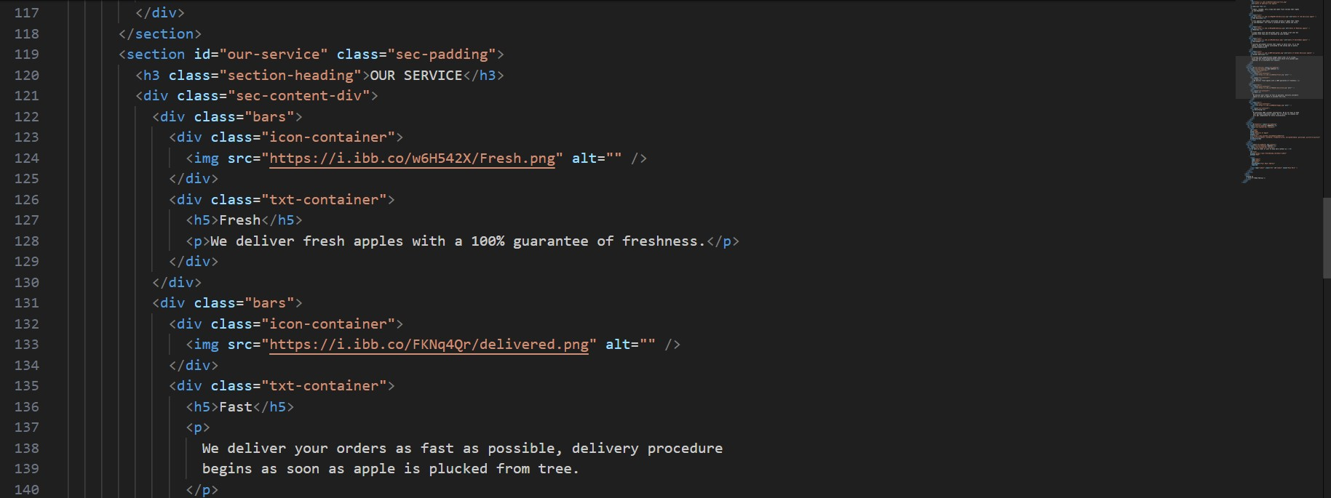

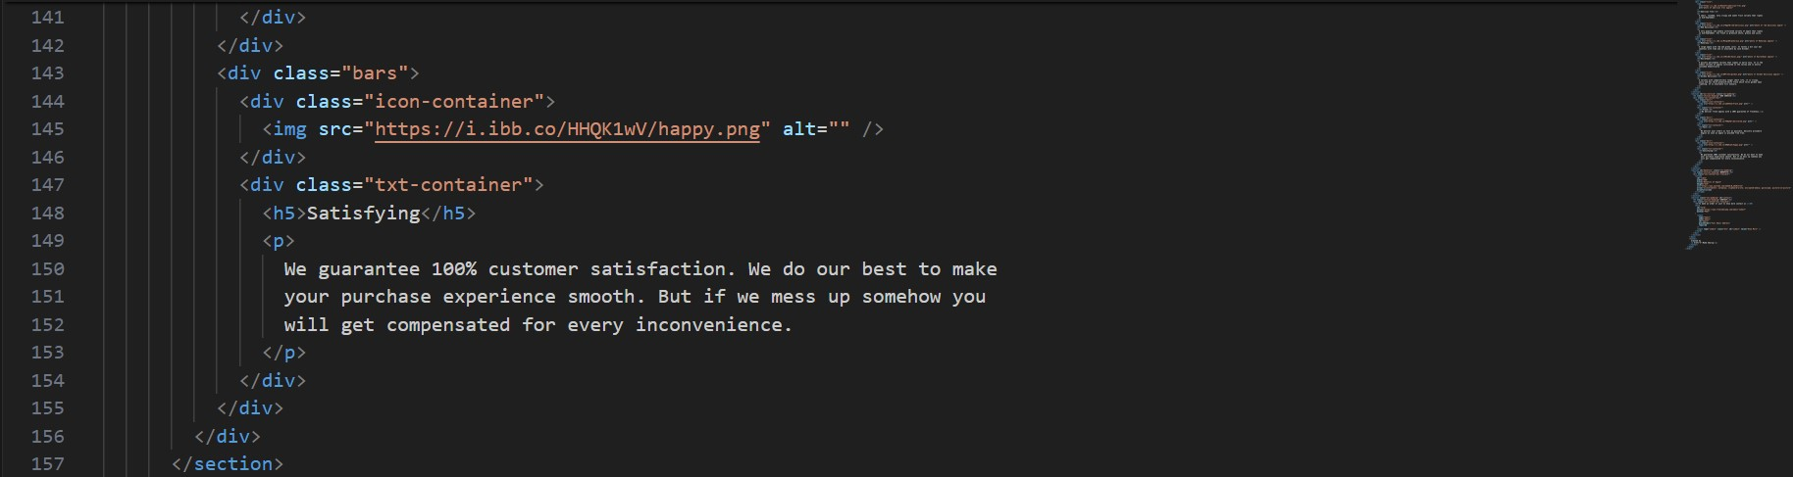

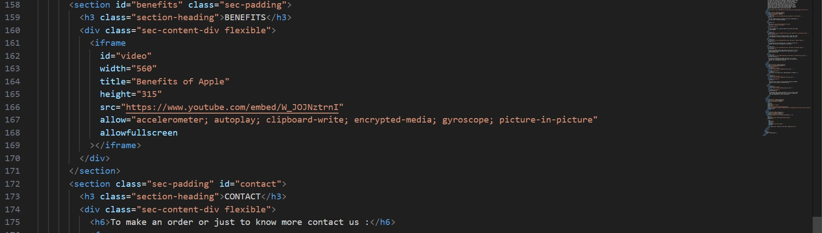

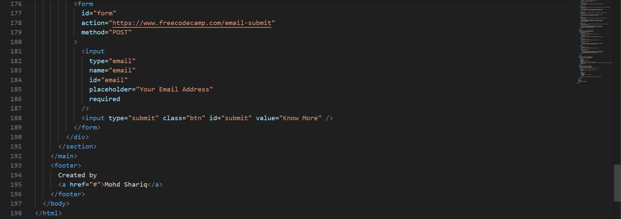

**CSS CODE.css** :

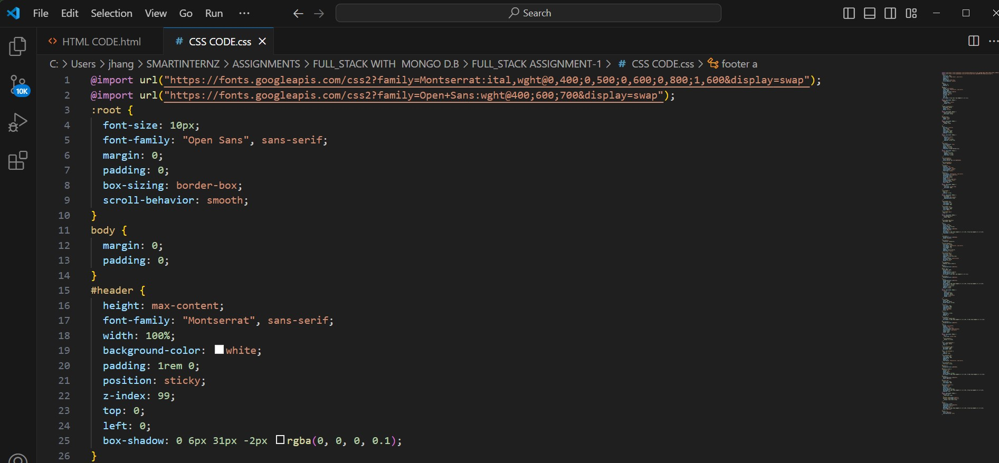



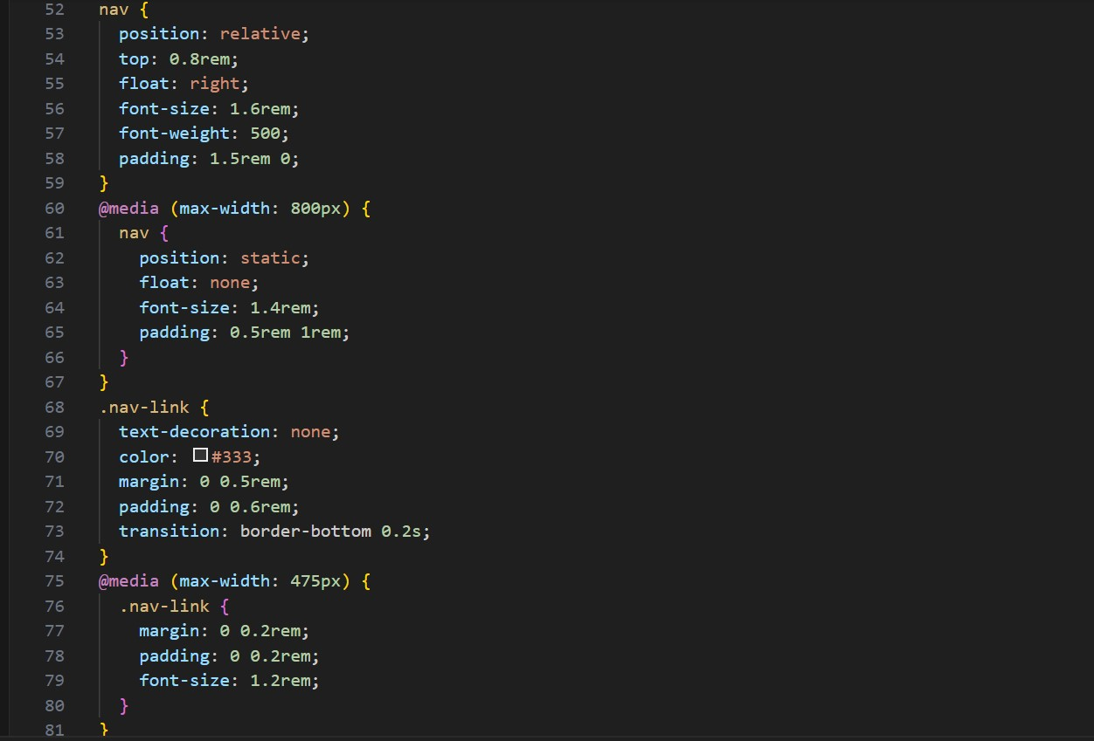





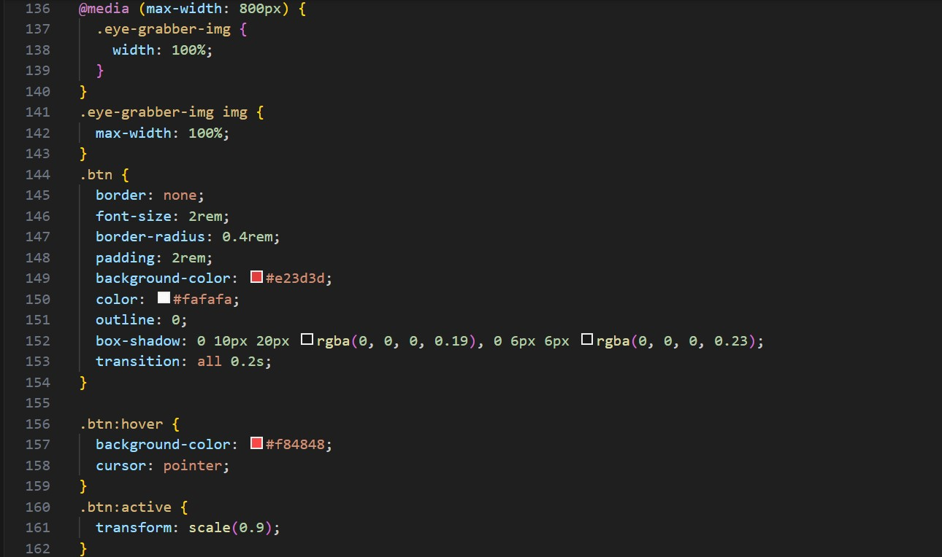

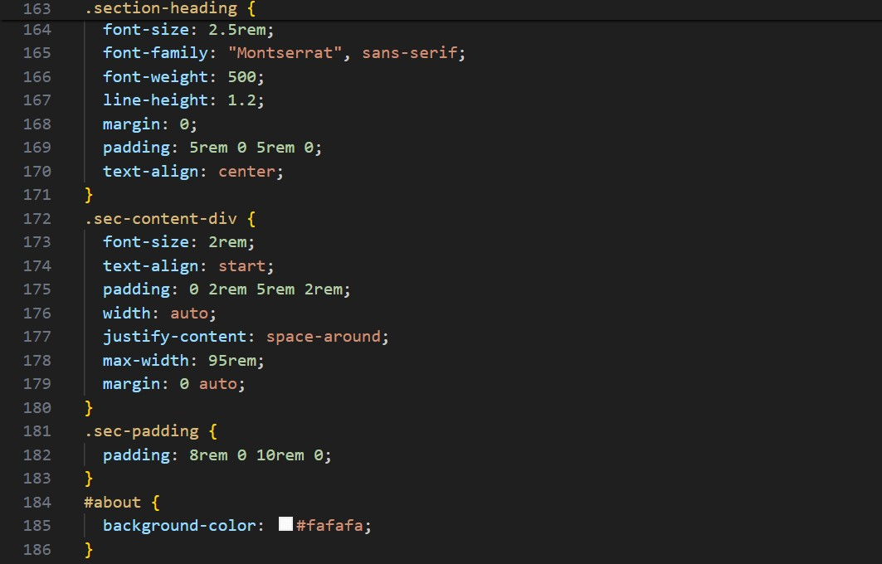

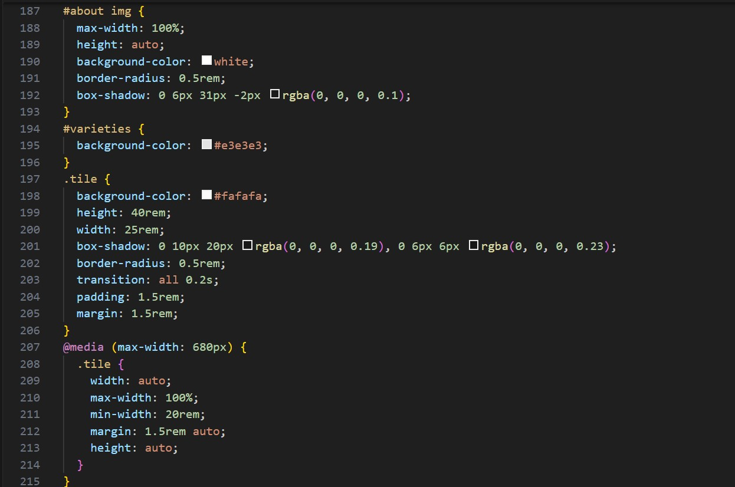

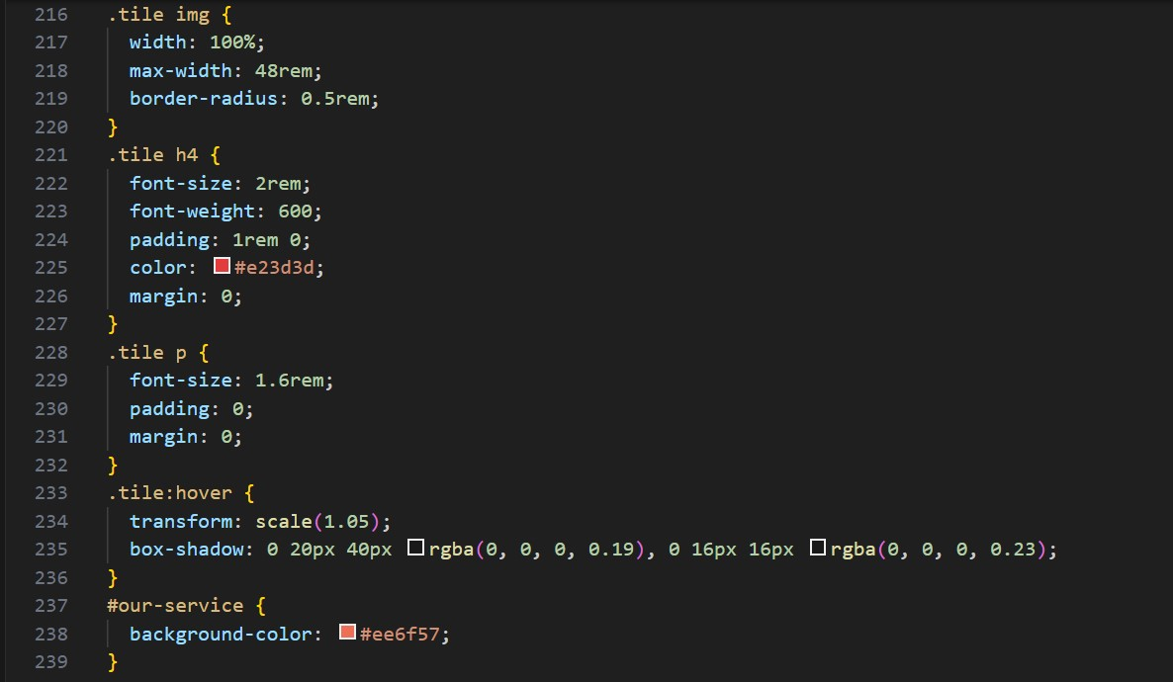

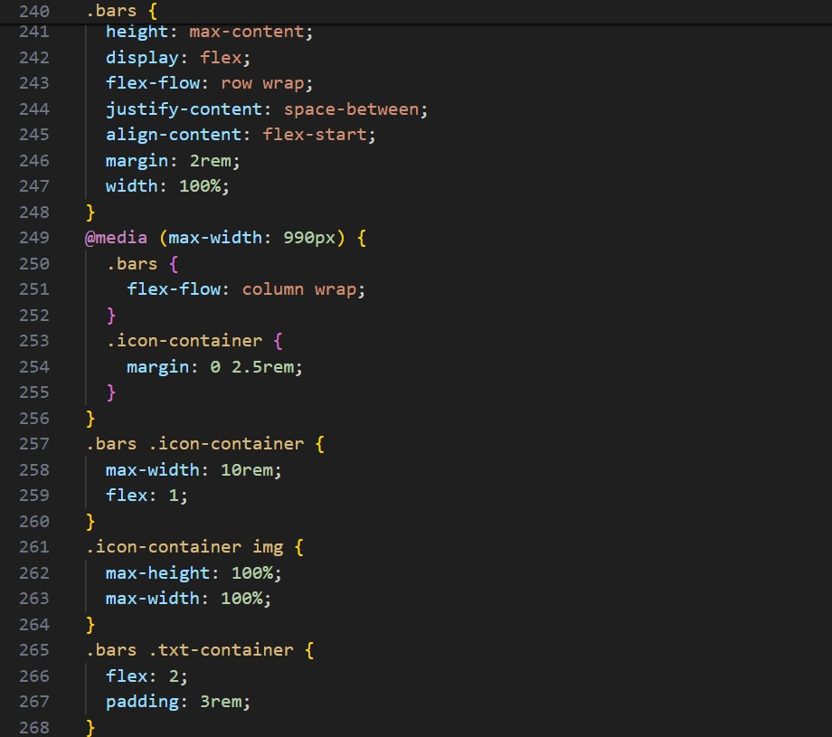

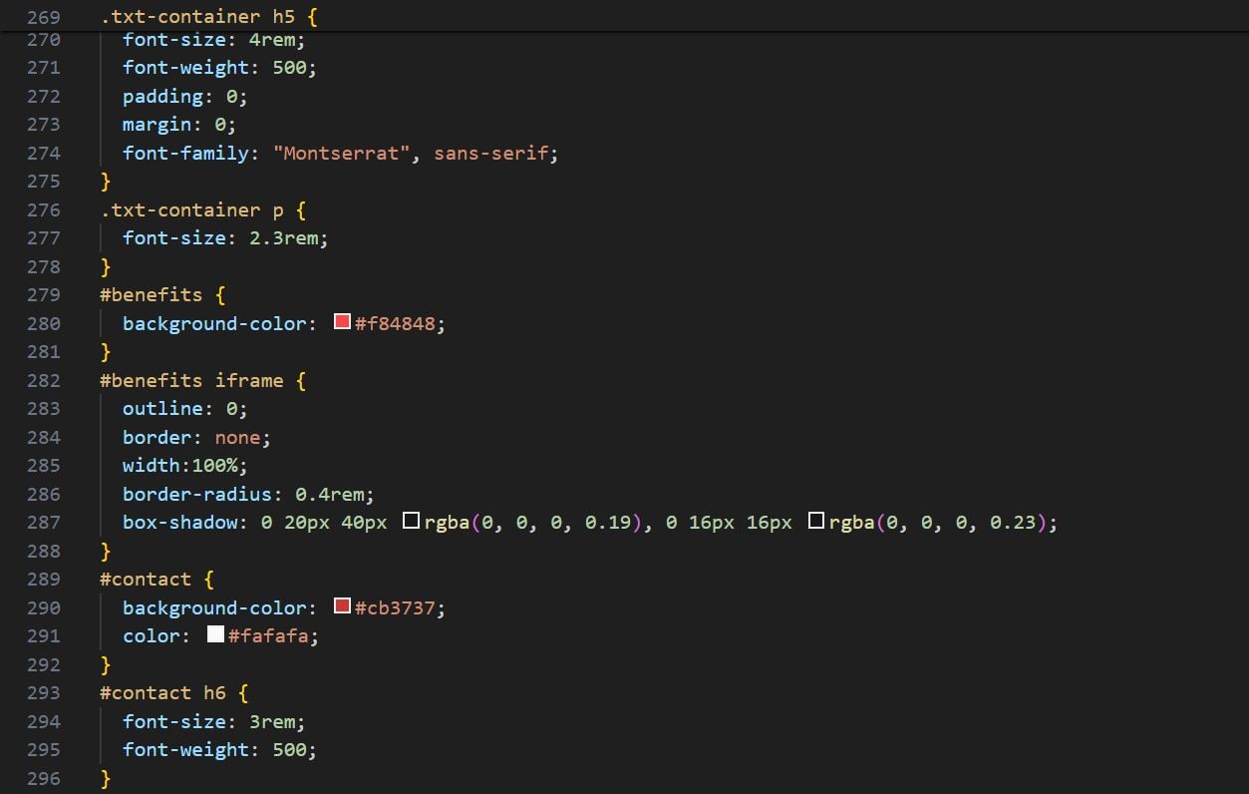

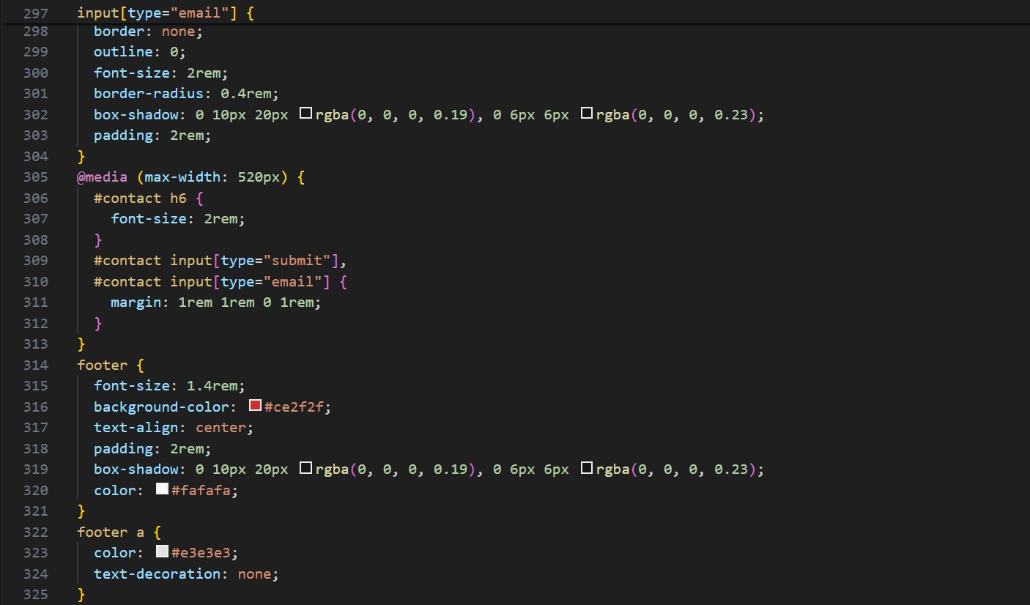

**OUTPUT** :



ABOUT VARIETIES OUR SERVICE BENEFITS

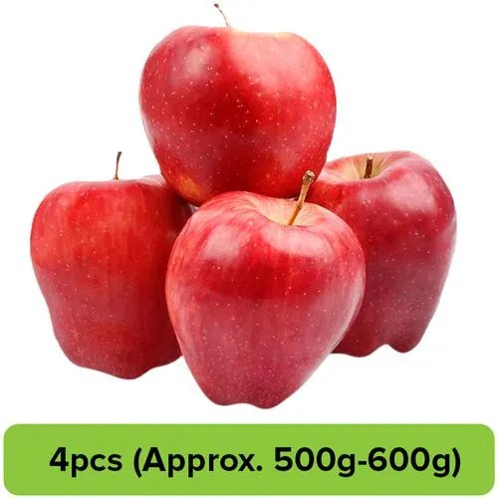

**Fresh, Crispy, Heavenly.**

**100% Organic, vivid varieties of apples grown in Kashmir aka The Heaven of Earth.**

Buy Now

**ABOUT US**

We are a group of people with decades of experience in growing and selling apples. We know what a good apple looks like and how they are grown. This essential fruit requires a temperate climate, loamy soil that is rich in organic matter apart from needing proper drainage and aeration facilities. Lucky for us we live in Kashmir which is proudly known as paradise of earth is also home to temperate fruits like apple for which the state is very famous across globe. The main factor which

influence temperate fruit bearing trees is soil, climate and environment which are highly favorable and unparalleled in the province of Kashmir. Kashmiri apples a unique look, taste, flavor, size and color.

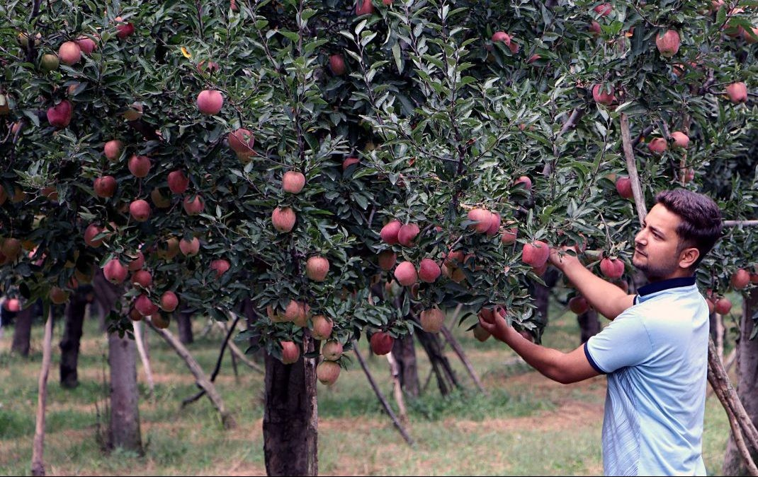

# VARIETIES

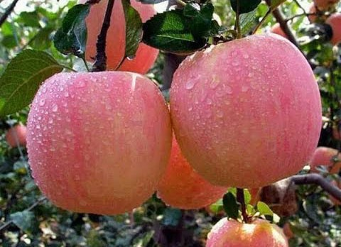

## Amber

This red, medium-sized fruit becomes fully ripe in mid-October. It is mostly grown in Shopian and Kulgam.

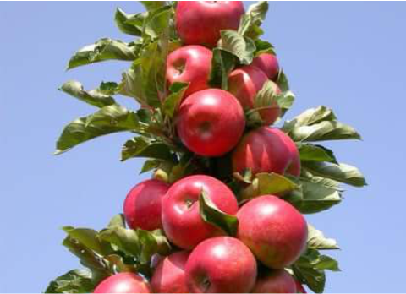

## American Trel

A small, rounded, very crispy and sweet fruit variety that ripens in mid-September.

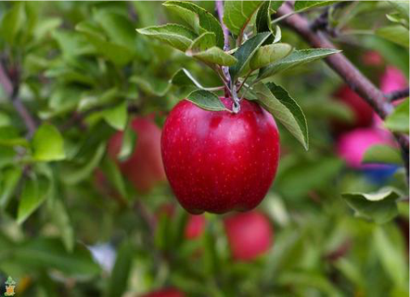

## Red Delicious

A very popular and widely cultivated variety of apple that ripens in mid-September. Its flesh is greenish white, grainy and juicy.

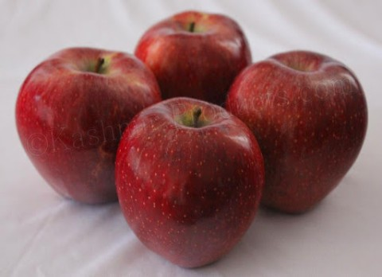

## Maharaej

A large apple with red and green color. It tastes a bit sour but sweetens with time and is available by late October.

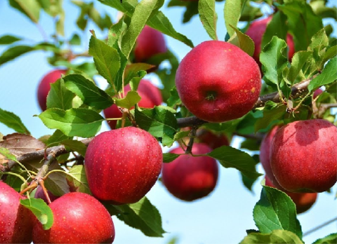

## Hazratbael

A quickly perishable variety that ripens in early July. It is the oldest variety of apples cultivated in the valley and is mostly consumed domestically

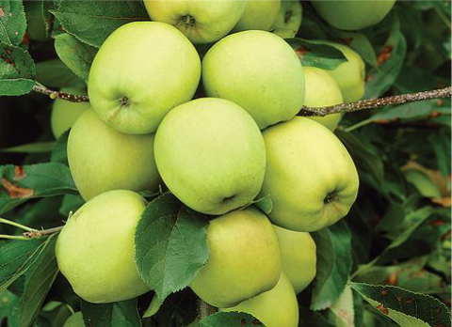

## Golden Delicious

A variety with comparatively longer shelf life, it is crispy, juicy and has thick greenish-white flesh which turns golden upon ripening. It is available till January.

# OUR SERVICE



**Fresh**

We deliver fresh apples with a 100% guarantee of freshness.



**Fast**

We deliver your orders as fast as possible, delivery procedure begins as soon as apple is plucked from tree.



**Satisfying**

We guarantee 100% customer satisfaction. We do our best to make your purchase experience smooth. But if we mess up somehow you will get compensated for every inconvenience.

# BENEFITS

[7 Health Benefits of Apple | Why Are Apples Healthy For Yo…](https://www.youtube.com/watch?v=W_JOJNztrnI)

**CONTACT**

**To make an order or just to know more contact us :**

Your Email Address

Know More

Created by Mohd Shariq